

**Capstone Design Proposal**

|  |  |
| --- | --- |
| Version | V1.2 |
| Recent Modify | 2019.03.25 |
| Member | 이동현, 공찬형, 금강현 |

**Team 11**

1. **Project Summary**
2. **Development Background**

The current reservation system for physical activity is too complicated and limited. Also It is hard to gather enough people for playing the official game like soccer, baseball and so on. Especially in Korea, the infrastructure for physical activity is inefficient so about 20% of people who cannot participating in physical activity point out the infrastructure as the main reason for not enjoying sports.

1. **Project Goal**

We’re trying to make the application ‘sports platform’ that people can use it for making a reservation on gym or sports facilities and getting an information about the physical activities. Also, they can participate in regular / non-regular competition and occupy gyms based on their records. The ‘ranking system’ will make the users feel more like ‘the game’ by filling out their records by regular / non-regular competitions. Result of the competitions would be used for the users’ personal records and team records. Theses records help the team or user to meet the appropriate team as an opponent.

There are some additional functions like ‘mercenary solider(용병)’ or ‘team recommendation in non-regular competition.’ Mercenary solider is, literally saying, the user who joins the team temporarily on regular competition. There might be some situation like the players for regular competition is not enough, and the user who can play for that game who is not belong that team. In that case, the user who made a reservation for that specific regular game can decide for the user to join the team temporarily.

The ‘team recommendation in non-regular competition’ is the service for recommending teams on non-regular competition. Because the most of member who belong to the game are strangers, so the only way they can get a reliable record for each member is from the app. The application determine the team based on each member’s records and recommend the team.

By these services, people can use the app as the sports platform, and enjoy sports as ‘the game’ in real.

1. **Project Function**

This app offers below three main functions.

1. Reservation
   1. Use Case
      * + Apply when you need a group booking for an official competition
   2. Rule
      * + There is a date for regular reservations every month.
        + You can select the desired place, date and time
        + If you make a reservation, no one can use the facility in same time.
        + Administrators can add and modify schedules separately
   3. Benefits
      * + Administrator can easily manage the schedule for a month
        + Users can have a priority to use the facilities
2. Matching System
   1. Use Case
      * + It is Additional reservations for those who did not apply at the Regular Reservation
        + Apply when you lack enough to play with
        + Apply when you want to exercise together with strangers
   2. Rule
      * + You can only apply for an unscheduled time during a regular reservation
        + Only available if you have collected a minimum number of people to care for people who use freely
        + Reservations are made with the approval of the administrator
   3. Benefits
      * + Users can easily find new members
        + It can encourage competition to further activate app use
3. Ranking System
   1. Group Management Service
      * + Members can create teams and recruit people to the team
        + You can play league with other teams
   2. Competition between Teams
      * + It records the history of the official game
        + Ranking by stadium and gym
   3. Team Composition
      * + Providing a service that matches teams with similar skills
        + Provides a service that automatically configures teams according to their skills
4. **Develop Environment**
5. Web
   * + - Spring Framework
       - JSP + Servlet
       - OpenAPI ([https://yeyakapi.seoul.go.kr](https://yeyakapi.seoul.go.kr/))
6. Web App
   * + - React Native
7. Server
   * + - AWS EC2
8. Database
   * + - MySQL
9. **Total Planning**

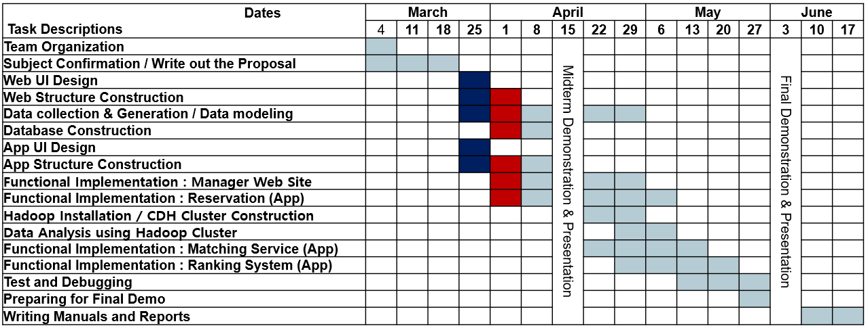

1. **Member Roles**
   1. Lee Dong Hyun
      * + Data modeling & gathering
        + Database Construction
        + Web server management
   2. Kong Chan Hyung
      * + Web page Design
        + Web page implementation
        + Web page test and maintenance
   3. Geum Kang Hyeon
      * + Web app Design
        + Web app implementation
        + Web app test and maintenance
2. **Project Expectation**

As you develop this service, you will encourage more interest and participation in life sports. Users can easily and quickly make reservations and easily recruit new people to play with. We also hope that this app will help you identify your competition and encourage competition to build your own league system within the service. After completing the development, we will add as much new functionality as possible to complete the integration system.